WHY NUCLEAR POWER
IS NOT SUSTAINABLE

- Uranium fuel is finite – All the uranium on our planet was created billions of years ago in another star system trillions of miles away. We’ve already mined the most accessible sources and at current (let alone expanded) rates of use, cost effective sources will be exhausted in about a century from now. Plutonium (man-made – in nuclear plants) is in some cases being substituted for uranium, but besides being the most toxic substance on the planet, increased use of it dramatically increases the risk of nuclear weapons proliferation.

- Nuclear power is NOT carbon-free/contributes to global warming – While a nuclear plant emits negligible CO2 in operation, the mining, milling, fabrication and especially enrichment of uranium fuel rods are very carbon-intensive. In fact, whole utility-size coal power plants are devoted to powering existing US uranium enrichment facilities. Also, the huge amount of materials, principally energy-intensive concrete, required to construct the necessary containment structures for nuclear plants is also very carbon- intensive. Conservative analyses have found that nuclear power is 7 TIMES more carbon-intensive than its closest renewable competitor – wind power generation.

- Nuclear Power is uniquely threatened by global warming impacts – all nuclear plants constantly require huge amounts of water to cool their superheated cores, and besides contributing to thermal pollution of lakes, rivers and bays, the plants simply can’t operate if their coolant water becomes too warm or is unavailable due to drought. And many nuclear plants are located at or near sea level and will be increasingly threatened by severe weather and sea level rise. Many nuclear plants in Europe had to shut down during an especially bad heat wave several years ago.

- Nuclear power is not resilient and adaptable to future power needs – nuclear power is only minimally cost-effective (see next item) when generated in huge centralized facilities which by their nature have to run on a continual basis (as “base-load” power). The necessity for immediate shutdown (known as a “scram”) of a nuclear plant whenever threatened by outside events or internal accidents means that blackouts and other crisis situations will be intensified very quickly, as demonstrated recently in Japan. Future needs for a “smart” power grid that is adaptable to rapidly changing circumstances does not mesh well with a centralized, inflexible and vulnerable power source like nuclear.

- Nuclear power can not exist without huge government subsidies – with recent growing focus on downsizing government and cutting back on unsustainable services and subsidies, it’s odd that little attention has been paid to the continuing billions of taxpayer dollars going every year to prop up a “mature” nuclear industry. These come in the form of tax breaks, government research and loan guarantees for new plants, not to mention the biggest subsidy of all – the Price-Anderson insurance policy which limits plant owners to about $12 billion in costs for major accidents. This policy continues despite numerous studies (and again, live demonstration in Japan) that project costs likely to be hundreds of times that amount – all bankrolled by you and me (if we survive).

- No one has figured out how to sustainably store radioactive waste for the tens of thousands of years required – the recently concluded nuclear storage project debacle in Yucca Mountain, Nevada leaves us with about 70 de-facto, unsecured, long-term nuclear waste dumps around the county. And other nuclear countries in Europe have fared little better, despite having 60 years now to grapple with the problem.

The Only Sustainable Energy Sources are Renewable -
Let The Sun And Earth Power Our Future!

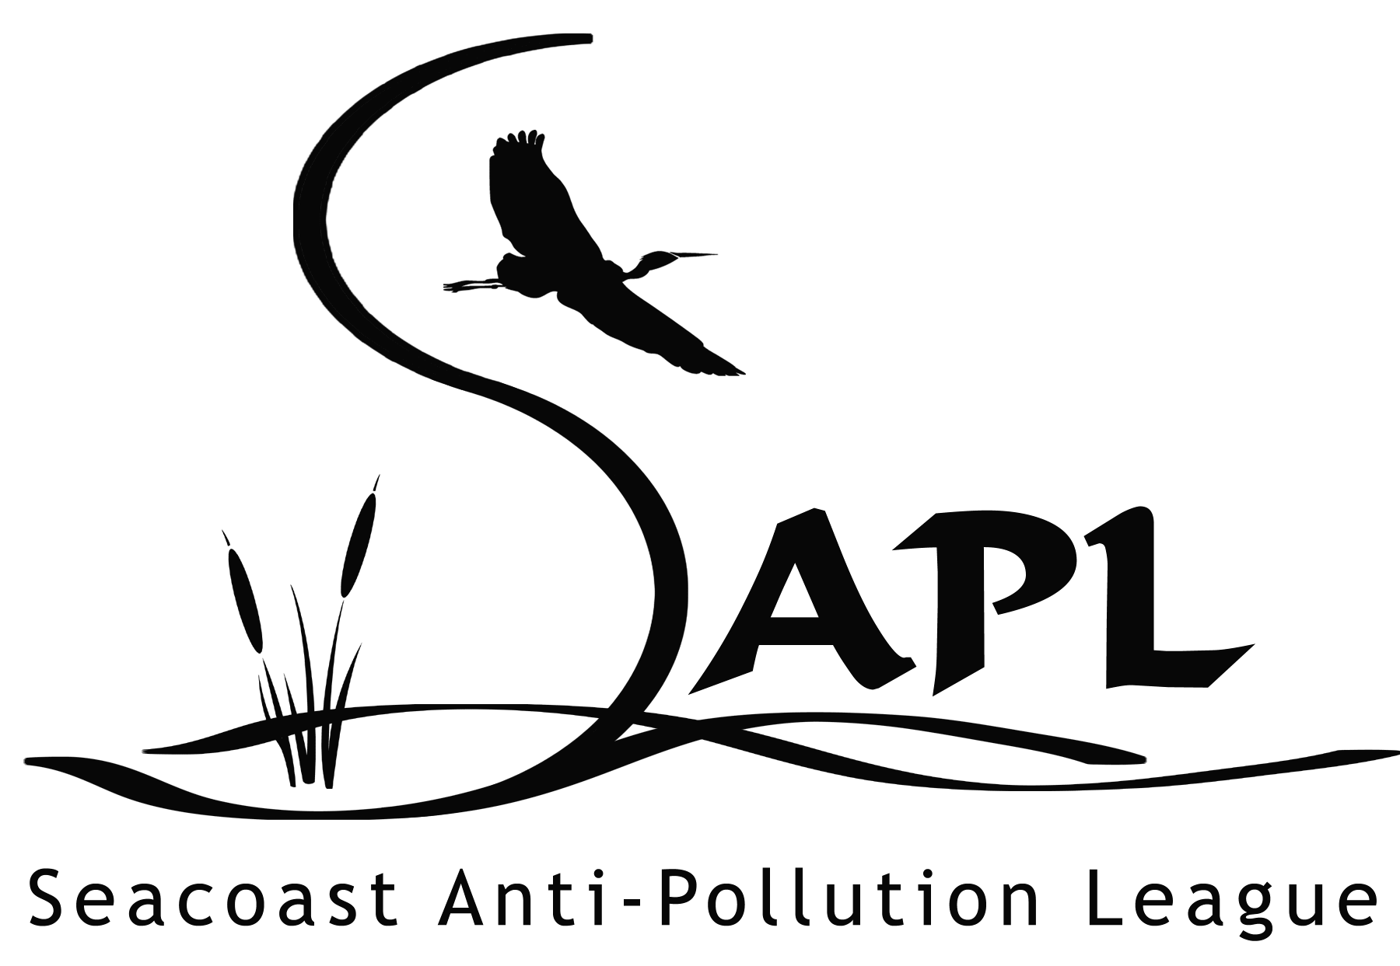
PO Box 1136
Portsmouth, NH 03802
(603)431-5089
Sapl.info@comcast.net

