Background

The Somali Bantu Community Association of Vermont was established in 2007 to meet the needs of the Somali Bantu refugee community, those placed in Chittenden County as a part of a resettlement program initiated in the United States in 1999. The Association has focused on education as a means of “bridging the gap” for refugees, immigrants, and low-income families and as such provides a wide range of workshops, programs, and classes. With the express goal of empowering and supporting beneficiaries to achieve economic and social independence and self-sufficiency, the Association is focused on equal access and opportunity for advancement and personal achievement.

Mission

Our mission is to facilitate the resettlement and integration of the Somali Bantu Community through providing educational, cultural and life skill training programs. We seek to promote English literacy, promote awareness of American culture, and encourage self-sufficiency within and among the individuals and families comprising the Somali Bantu Community in the United States, especially in Vermont. As part of our mission, we also support not only the Somali Bantu community, but also any fellow community member in need of service.
Donations
To make tax deductible gifts to the Somali Bantu Community Association of Vermont, Inc., please make checks payable to SBCAVT and mail to the association address below. Any donation, no matter how small, will greatly aid us in accomplishing our mission. Thank you.

Somali Bantu Community
Association of Vermont, Inc.
294 North Winooski Avenue, Suite 212B
Burlington, VT 05401

Phone: 802.658.2683
Fax: 802.264.9633
Email: sbcavt@somalibantuvermont.org
Website: www.somalibantuvermont.org

Thank you for your support.
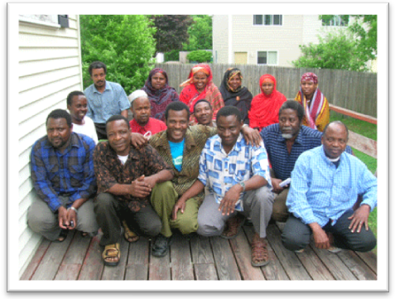

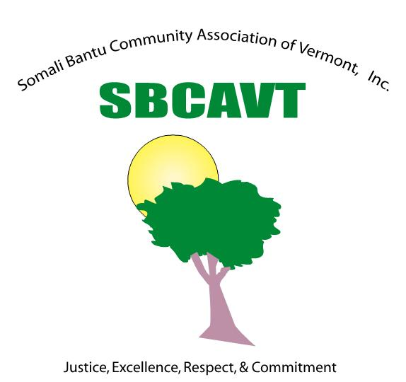

Programs
The Reparative Probation Project
This project is devoted to repairing and addressing the damage caused by crime.
As such it provides both legal advice and counseling for low-level offenders and their families.

New Father Initiative Program
The New Father Initiative Program is devoted to helping refugee community fathers adjust to living in the United States and in giving them the support and resources they need to continue being strong, positive role models for their children. With that in mind, the Association currently provides weekly meetings in which fathers are given the opportunity to voice their own concerns about parenting and to explore various themes and questions associated with fatherhood as it relates to the refugee experience in the United States.
Vital Information Program
This program provides educational workshops and classes devoted to English literacy and job-skills training and development. The program also provides translation services for both written materials and class lectures in an attempt to make all programming fully accessible to beneficiaries regardless of their current English proficiency.
Youth Recreational Program
The SBCAVT currently supports two soccer teams with 36 players. These teams are open to young men ages 16-26. The teams play locally in Chittenden County, VT, but also travel to surrounding states for competitions, specifically NY, NH, ME, and MA. Currently the program is only available in the spring and summer, with practices beginning in May. The Association is seeking funding for a women’s team and hopes to expand this program by summer 2011.
Community Support Program
This program provides the Somali Bantu Community with administrative services, translation and interpretive services, aid with human services paperwork, referrals, transportation services, assistance in finding affordable housing, assistance in procuring sustainable employment and provides a free computer lab for community use.
Knitting Group Project
This project was developed by the Women’s Committee as a social network for refugee women and as a means of preserving traditional crafts. It has served as one outlet for supporting refugee women in developing friendships and connections with others in similar circumstances.
Tabar Women’s Leadership Program
The Tabar Women’s Leadership Program is devoted to the needs and concerns of refugee women adjusting to living in the United States. The program features job skills training, financial literacy workshops, English literacy classes, and career support. In addition, it maintains a mentor network linking Burlington community professionals to aspiring women and weekly support meetings devoted to the challenges of parenting in the United States. The program is overseen by our Women’s Committee and is provided by and for women in an effort to create a safe and comfortable learning environment for the growth and development of women leaders.
