

Access Rights Primer
Living carfree should not make you a second-class citizen. Accessibility rights would ensure that individuals who cannot or choose not to drive can enjoy equal access to opportunities as auto-mobile individuals. Opportunities include shopping, educational facilities, public amenities, employment, recreational areas, and all other destinations. While this concept of accessibility rights is rooted in existing legislation, there are currently no explicit legal protections or rights for carfree individuals. In most of the United States, carfree individuals experience significant barriers to opportunities, practically necessitating automobile ownership.

Sustainable Transportation
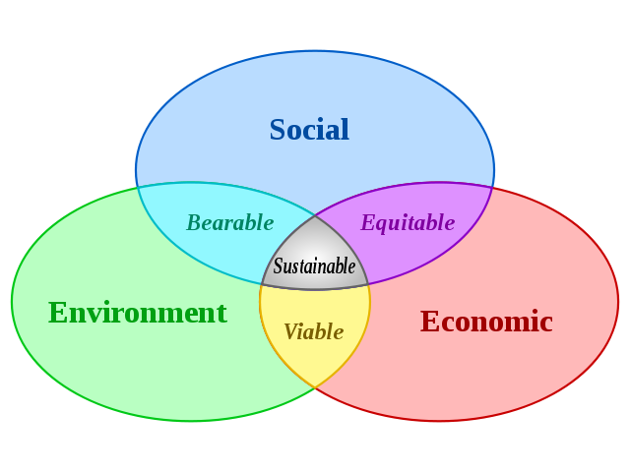
In developing a sustainable transportation and land use system, it is critical to balance social, economic, and environmental systems. Focus is often placed on environmental sustainability (with good reason – without it, society and an economy would not exist). However, it is very important to consider equity –the sustainability of our social and economic systems.

History of transportation inequity

We have an impressive highway system. Although a road is rarely thought of as a “place”, every square foot of pavement is a former farm, forest, or neighborhood. Especially in cities, highway development is paired with urban renewal and slum clearance. In nearly every city, low-income neighborhoods have been cleared for limited-access highways. In these situations, dislocated residents lose homes and businesses. Remaining residents experience reduced access, with destinations literally blocked by the highway.

This is the legacy of a transportation system designed to increase mobility for automobiles. In turn, land use has been optimized for automobile use, with large parking lots, “super”stores, and suburban development. All this has been at the expense of carfree individuals. For many individuals, daily needs and necessary destinations are simply too far apart to be accessed without an automobile. The automobile-oriented transportation policies and infrastructure of the 20th century are unsustainable.

Only land use optimized for access (people, not cars) can systematically reduce our dependence on automobiles. However, public transit is a good stop-gap measure current transportation inequality. In order to overcome some of the transportation burden experienced by carfree individuals, the federal government funds transit in urbanized and rural areas generally, and several programs for target populations. Specialized programs include:
- USC 5317: New Freedoms – To reduce barriers to transportation services for workers with disabilities
- USC 5316: Job Access and Reverse Commute – To provide access to employment for welfare recipients. A special focus on suburban employment locations.
- USC 5310: Elderly Individuals and Individuals with Disabilities Program- To provide additional transportation where existing transit service does not meet the needs of elderly and individuals with disability(s).

However, these federal funding programs are not enough to overcome the systemic exclusion experienced by carfree individuals. Only legal recognition of access rights can ensure transportation justice.

Statistics

- 3.5 million people in the United States never leave their home.
- 15% of workers living on the Portland Peninsula have no vehicle.
- 20% of Mainers have a disability which may prevent them from operating a vehicle.
- 23% of Mainers are unlikely to drive alone due to age restrictions.
-16% (under 18)
-7% (75 and older)

Legal basis for access rights

The foundation of access rights is based in existing legal protections. Existing protections include:

Title 6
Title 6 of the 1964 Civil Rights Act forbids discrimination based on race, color, or national origin in services receiving federal funds shall. Further, it charges that federal funding agencies (such as the DOT) take action to enforce this policy.

National Environmental Policy Act
NEPA, passed in 1970, require federally funded projects and activities to conduct an Environmental Impact Study, or to show that no study is necessary. Social and cultural impacts are a required part of NEPA, and this requirement was honed with the executive order on Environmental Justice.

Olmstead v. L.C. (1999)
This supreme court ruling requires states to eliminate unnecessary segregation of persons with disabilities, to ensure individuals receive services in “the most integrated setting appropriate to their needs.” The civil rights division of the Department of Justice is actively enforcing this ruling. This ruling paves the way for community living and services for other institutionalized populations as well, such as children, elderly.

American Disabilities Act
The ADA of 1990 prohibits discrimination and ensures equal opportunity and access for individuals with disabilities. The ADA has been enforced to improve access to transit services and better pedestrian and wheelchair facilities in the built environment. The ADA has also provided justification for FTA funding programs that seek to improve transportation options for individuals with disabilities.

Environmental Justice
In 1997, title 6 was expanded to address environmental justice for minority and low-income populations. In a transportation context, environmental justice is based on three principles:

- To avoid, minimize, or mitigate disproportionately high and adverse human health or environmental effects, including social and economic effects, on minority populations and low-income populations.
- To ensure the full and fair participation by all potentially affected communities in the transportation decision-making process.
- To prevent the denial of, reduction in, or significant delay in the receipt of benefits by minority populations and low-income populations.

Maine Sensible Transportation Policy Act
The Maine STPA, passed in 2003, requires land use impacts to be considered in transportation projects. The STPA goes above and beyond NEPA. However, no case has been successfully brought against a Maine DOT project under the STPA.

Advocacy

The Transportation Equity Network is a national organization with a staff of 5 and over 350 member organizations. Other states and cities have organizations that advocate for transportation justice. For example, the Boston area has On The Move and the Livable Streets Alliance with a strong track record for collaboration and success.

In Maine, there are several organizations that advocate around transportation issues. However, no organization expressly advocates for access rights. GrowSmart Maine, the Bicycle Coalition of Maine, Visible Community, and Portland Trails are well-known and effective advocates for sustainable transportation options.

Gaining and ensuring rights of access are central to the mission of the Maine Alliance for Sustainable Transportation. Individuals members and partner organizations are invited to join us in advocating for a more just and accessible land use and transportation systems in Maine.

Fitzpatrick, D. (2000). The story of urban renewal. Pittsburgh Post-Gazette, May 21.
Lewis, Tom. 1997. Divided Highways, Harmondsworth, England: Penguin books.
Bureau of Transportation Statistics. 2003. Freedom to Travel.
US Census Bureau 2000. Transportation Planning Package.
US Census Bureau. 2000. 2000 US Census.
US Census Bureau. 2009. American Community Survey.
http://www.ada.gov/olmstead/index.htm
http://hawaii.gov/dot/administration/ocr/title6/title-vi-faq

