C:\Documents and Settings\Owner\Local Settings\Temporary Internet Files\Content.IE5\C6QOQVA6\MCAN02097_0000[1].wmfC:\Documents and Settings\Owner\Local Settings\Temporary Internet Files\Content.IE5\7NO669GC\MCj04300610000[1].wmf

# Flints Pond

Hollis, NH

A place worth saving!

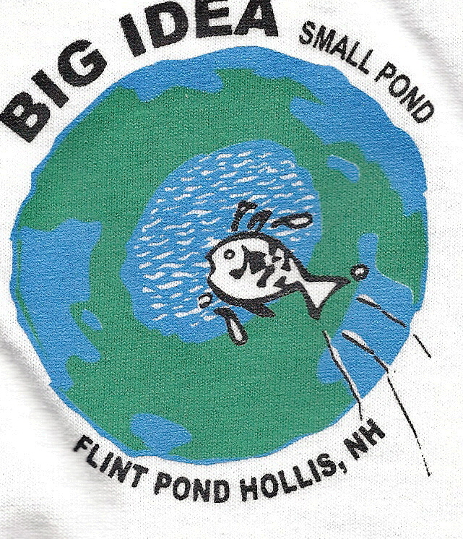

**VOTE YES ON**

**WARRANT ARTICLE 7**

**Attend Town Meeting**

**March 10 & 11, 2010 @ 7pm**

**Hollis Brookline High School**

Attend Town Meeting

March 10 & 11, 2010 @ 7pm

Hollis Brookline High School

**How can I help? Education/Prevention**

DES Exotic Weeds Program www.des.nh.gov/organization/divisions/water/wmb/exoticspecies/

NH Lakes Association Education and Lake Host Program helps educate and prevent boaters from spreading milfoil, Flints Pond has participated in the program. [www.nhlakes.org](http://www.nhlakes.org) bottom of home page 7min video: *NH Lakes Under Attack*

Watch *Notes From Flint Pond,* a 5 minute video playing on Channel 12 on Saturdays and Sundays at 9:30am, 12 noon and 5:30pm.

See what other lakes & ponds have done to control Milfoil at these websites:

[www.dudleypond.org](http://www.dudleypond.org)

[www.ossipeelake.org/news/2010/02/06moltonborough-prepares-200k-assault-on-milfoil/](http://www.ossipeelake.org/news/2010/02/06moltonborough-prepares-200k-assault-on-milfoil/)

**VOTE YES ON WARRANT ARTICLE 7**

**Attend Town Meeting**

**March 10 & 11, 2010 @ 7pm**

**Hollis Brookline High School**

Flint Pond Improvement Association is a Non-profit 501(c)3 Organization

**Flint Pond Improvement Association**

Hollis, NH

www.flintspond.org

person and globe

**Frequently Asked Questions About**

**Flints Pond**

1. What is Milfoil?
2. The Milfoil that plagues Flints Pond is a non native invasive water weed, it can grow up to 15 feet long and spreads quickly from just a fragment of the plant.

Q. Can Milfoil be spread to

other lakes and ponds?

1. Yes, boats and boating equipment should be checked and cleaned for remnants of plant life before and after boating again. Milfoil can dry out for 2 weeks and be revived when it returns to water.

Q. How can Milfoil

infestations be controlled?

1. Control Methods: Education

Mechanical harvesters, i.e.

Hydro-raking

Herbicidal controls, spot treatment

Ref. [www.des.nh.gov](http://www.des.nh.gov) for full listing of control methods

C:\Documents and Settings\Owner\Local Settings\Temporary Internet Files\Content.IE5\ASQ3OPJU\MCj04247100000[1].wmf

### Benefits Overview

Flints Pond is a natural resource that supports a variety of aquatic life and a potential water supply for the Hollis area.

* Fishing and boating revenues for the state
* Restores the natural habitat
* Provides recreational usage of Flints Pond for the residents of Hollis via a state boat launch and town owned lot
* Prevent spread of Milfoil to other lakes and ponds
* Maintain an emergency water supply

C:\Documents and Settings\Owner\Local Settings\Temporary Internet Files\Content.IE5\RZUTWJML\MCAN01883_0000[1].wmf

Q. Who is recommending the treatment

plan?

A. NH Department of Environmental

Services (DES)

Hollis Board of Selectmen

Hollis Conservation Committee (HCC)

Hollis Budget Committee

Flint Pond Improvement Association

Q. What is the plan for Flints Pond?

A. 2010- Hydro-raking

2011 DES treatment of Milfoil

2012 DES certified divers

2017 Maintenance Hydro-raking

Q. Where will the money come from?

A. $106,000 The Flint Pond Restoration

Capital reserve Fund

$ 14,700 DES/ NH Lakes Grants

$ 9,800 HCC Flints Pond Fund

$ 24,300 Flint Pond Improvement

Association fundraising

$154,800

Future restoration efforts to be funded

by DES/ NH Lakes grants and

fundraising efforts by the Flint Pond

Improvement Association.

Q. Will this effect the tax rate?

A. NO. Releasing the money from the Flint

Pond Restoration Fund will not affect

taxes. This money was set aside and

saved for this purpose beginning in 1994.

For information on open positions or to submit your resume, please visit our Web site at: www.lucernepublishing.com