FOR IMMEDIATE RELEASE (has not been sent to press yet)

Contact Elizabeth Golden-Pidgeon
elizabethgolden@shoreham.net
802-385-1911
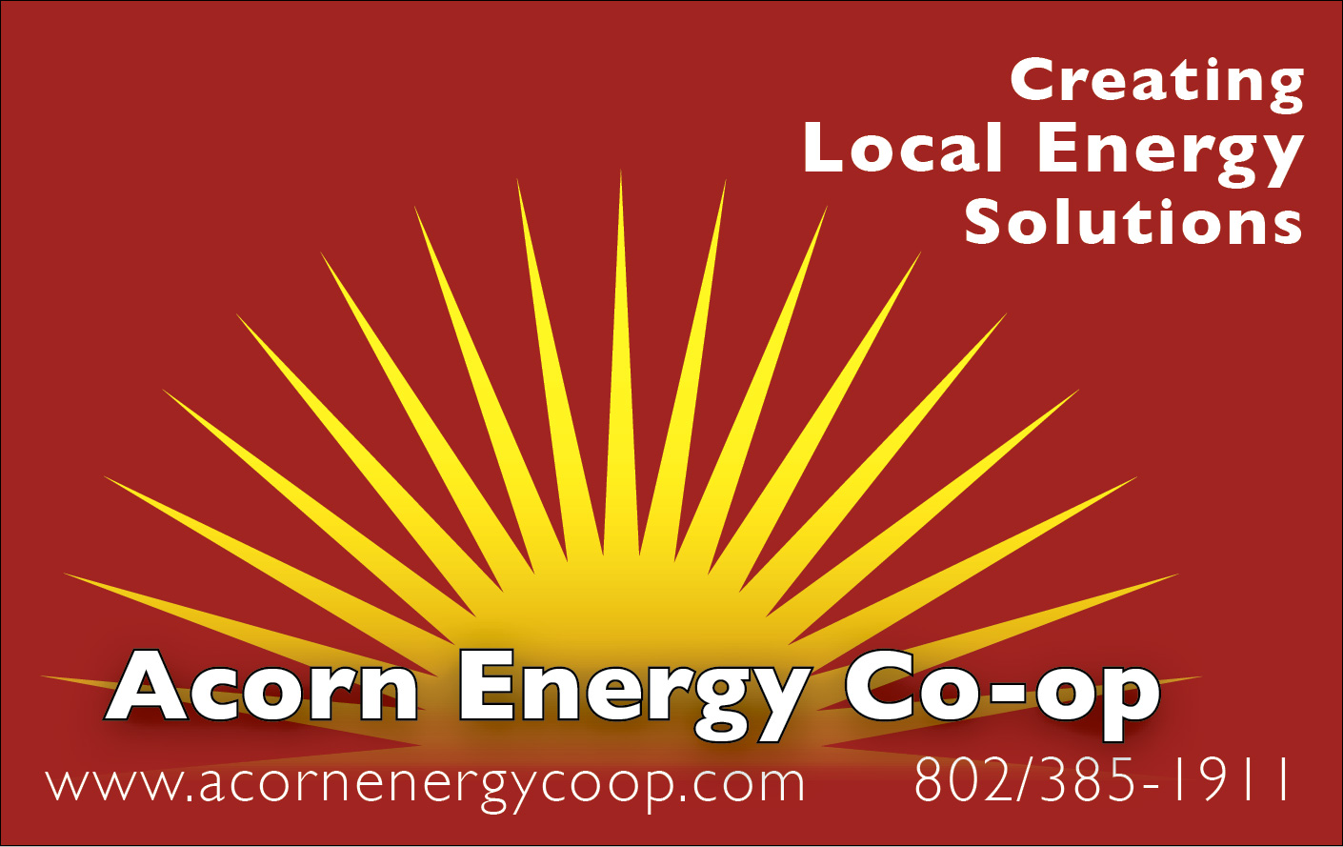

Acorn Energy Co-op Announces Upcoming Energy Education Series

Opening program features presentations on cordwood and wood pellets, and the issues associated with heating with wood in Vermont.

Middlebury, VT, September 12, 2011 – Acorn Renewable Energy Co-op, a member-owned energy cooperative, and The Addison County Regional Planning Commission (ACRPC) announced today a second season of the Energy Education Series, which kicks off with “Sustainable Energy Options: Wood and Pellets” on Wednesday, September 21 at 7:00 p.m. at the Ilsley Library Community Room, 75 Main Street (rear entrance) in Middlebury. The informal and interactive two-hour presentation and discussion will feature local energy experts, who will cover the pros and cons of various residential wood biomass sources and systems (cordwood and pellets).

Vermonters interested in learning more about wood as a heating fuel or about the Co-op are urged to attend. The event is free, and preregistration is not required.

“We are very excited to continue with another season of the energy series to help our Co-op members and others throughout the region learn more about their energy options, so they can make smart and environmentally sound decisions for their businesses, homes, and for the future of our community,” says Greg Pahl, Acorn Energy Co-op Board President.

Throughout the fall, the Co-op’s Energy Education Series will cover additional topics, focusing on energy efficiency, conservation, and renewable energy issues, on October 19, November 16 and December 7. All Energy Program presentations feature energy and conservation experts, include Q&A, and are held at Ilsley Library. Contributing sponsorship opportunities are still available.

The Co-op is also planning energy facility and home tours on topics such as group net metering and solar hot water systems, and welcomes additional program suggestions.

The Co-op also publishes an Acorn Energy Resources Directory, which includes the names and profiles of over 100 local organizations, businesses, or programs, each devoted in their own way to helping members and clients make smart energy choices for businesses and homes. For more information on the Co-op, the Energy Series, and the Resource Directory, visit www.acornenergycoop.com.

- more -
About Acorn Renewable Energy Co-op
The Acorn Renewable Energy Co-op is a member-owned energy cooperative serving residents and businesses in Addison, Rutland, and Chittenden counties. The Co-op provides education, outreach, services, and products that help members of area communities take steps to make the transition from our present reliance on fossil fuels to greater use of renewables and local solutions. Members pay $35 annually and receive discounts from affiliates and partners on energy products and services, as well as discounts from local community partners on products and services, including restaurants, apparel, office supplies, and books. Members participate in the Co-op, and share these rights together: Democratic participation in decision-making, joint purchasing, community-scale sustainable energy development, member education, public outreach and advocacy. For more information, or to join the Acorn Renewable Energy Co-op please visit www.acornenergycoop.com or call 802-385-1911.

# # #

