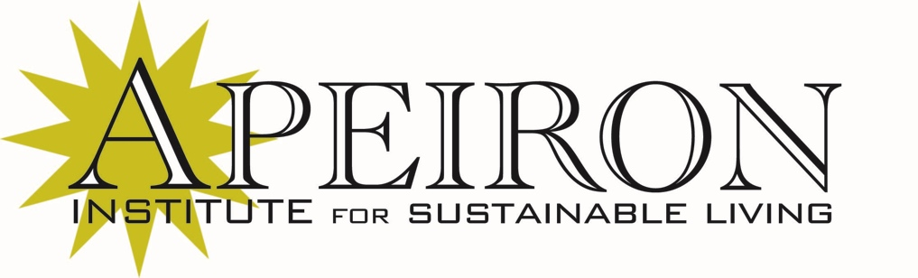

355 Hope St., Second Floor, Unit 6

Providence, RI 02906

Tel: 401-228-7930

Fax: 401-228-7932

Email: info@apeiron.org

Web: www.Apeiron.org

September 14, 2011

To Whom It May Concern:

I am writing this letter in support of the application of Jed Greenberg for funding to conduct a series of workshops on Sustainable Communities, as well as to foster a network of Sustainable Community Leaders in Rhode Island through the work of this initiative.

The Apeiron Institute for Sustainable Living looks forward to being a partner in this project and conducting Community Leader training in facilitation of discussions and working group sessions on Sustainability for community members. There has never been a better time to develop the kind of education and community outreach program that Mr. Greenberg is proposing – in our ongoing daily interactions with members of our own communities, we have seen an enthusiasm for and readiness to learn about and engage in discussions of sustainability as never before.

For all of these reasons, we offer our unqualified support to Mr. Greenberg’s initiative.

Sincerely,

Ken Ward

Executive Director

Sustainable Business Training & Education

Apeiron Institute for Sustainable Living